

**MACAU UNIVERSITY OF SCIENCE AND TECHNOLOGY**

**School of Computer Science and Engineering**

**Faculty of Innovation Engineering**

**<<Software Project for Course Software Engineering>>**

Homework ID : Task1-Project Proposal

Report Title : **Campus Second-hand Trading Platform**

Student Name : Wang Zhaohan, Zhang Zhichao, Chen Baifu

Student No. : 1230016747 1230035596 1230019994

Group Number : 7 (Seven)

Date : 2025.09.28

# Abstract

This project aims to design and implement a campus second-hand trading platform that focuses on the real needs of university students. At present, most second-hand trades happen in small social media groups or chat apps, where information is scattered and difficult to manage. This often causes students to miss opportunities to buy affordable items or sell unused belongings.

The proposed system will provide basic but practical functions: user registration and login, item posting with details and images, keyword and category-based searching, transaction tracking, and automatic notifications. Our team will also add a simple recommendation method to increase the chance of successful matches.

The final platform should offer value to students by lowering transaction costs, creating a safer and more organized campus trading environment, and encouraging recycling and efficient resource use within the university.

# 

# Table of Contents

Abstract 2

Table of Contents 3

List of Figures 4

Chapter 1 Introduction 5

1.1 Background Overview 5

1.2 Team Profile 5

Chapter 2 Problem Diagnosis 6

2.1 Current Situation Analysis 7

2.2 Core Problem Identification 8

2.3 Impact Assessment 10

Chapter 3 Proposed Project Description 11

3.1 System Features 11

3.2 Business Value 11

3.3 Example Scenario 11

Chapter 4 Proposed Project Description 12

4.1 Timeline 12

4.2 Product Ownership 12

4.3 Technology Stack (Preliminary decision) 13

References 14

# List of Figures

Figure 1 6

Figure 2 8

Figure 3 10

# 1. Introduction

1.1 Background Overview

Student life generates a variety of second-hand needs every semester. Many items—such as textbooks, lab equipment, small appliances, and personal belongings—become idle when courses finish or students graduate. Without an effective exchange platform, these unused resources either remain in dorm rooms or are discarded, which is wasteful.

So far, the common method has been through chat groups or small online posts, but this method has clear problems: information gets buried quickly, buyers struggle to find what they want, and sellers cannot reach enough potential customers.

This project aims to solve these problems by building a campus-specific second-hand trading platform. The platform will centralize exchange information, allow easy posting and searching, and connect buyers and sellers directly inside a safe student environment. Although our system will be simple, it is realistic and useful for daily student life and directly applies the concepts we are learning in software engineering.

1.2 Team Profile

Team Name: Fish Club

Team Leader: Wang Zhaohan (Acting as a facilitator, to organize the whole group)

Member Profile:

|  |  |
| --- | --- |
| Member | Qualifications and strengths |
| Wang Zhaohan (Leader) | Specializing in python programming, front-end development and data management. |
| Zhang Zhichao | Specializing in specializing in back-end development and database design. Also being good at giving presentation. |
| Chen Baifu | Specializing in technical requirement communication and project development document writing. |

# 2. Problem Diagnosis

2.1 Current Situation Analysis

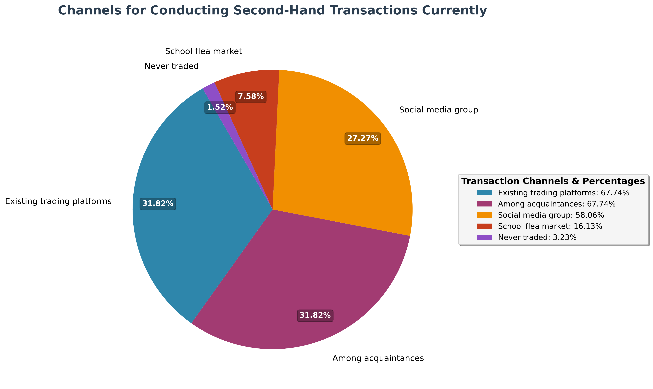

Figure 1

**a) Communication Groups as One of the Primary Trading Channels**

Currently, student trading usually occurs through informal communication platforms such as WeChat groups, QQ groups, and campus forums. This approach presents several inherent limitations:

1. Information Overload: Popular trading groups can generate hundreds of messages daily, causing individual listings to be buried within minutes of posting. Students report spending significant time scrolling through chat histories to find relevant offers.
2. Fragmented Communication: Transactions are scattered across multiple unrelated groups, forcing users to monitor several platforms simultaneously. A seller might post in 3-5 different groups to increase visibility, while buyers must check multiple sources to find desired items.
3. Temporal Limitations: Trading activity peaks during specific hours (evenings, weekends), creating intense competition for attention during these periods while leaving other times with minimal activity.

**b) Absence of Systematic Organization**

1. The current ecosystem lacks fundamental organization mechanisms that are standard in modern trading platforms:

2. No Standardized Categorization: Items are described inconsistently - "textbook," "used book," "course book" might refer to the same category. This ambiguity makes systematic browsing nearly impossible.

3. Limited Discovery Tools: Without keyword search, filtering, or sorting capabilities, students rely exclusively on manual browsing. Valuable items often go unnoticed simply because they were posted during low-activity periods or used unconventional descriptions.

4. Geographic Inefficiencies: Even within the same campus, students have no way to filter items by proximity (dormitory areas, academic buildings), leading to unnecessary logistical challenges for item exchange.

**c) Unstructured Transaction Processes**

The post-initial contact phase suffers from significant process gaps:

1. Manual Follow-up Dependency: Once interest is expressed, both parties must manually track the conversation through chat history. Important details like meeting times, locations, and price negotiations get lost in ongoing conversations.
2. No Status Tracking: There's no mechanism to indicate whether an item is still available, pending sale, or already sold. This leads to multiple students inquiring about the same item and sellers having to repeatedly update their status.
3. Accountability Issues: Without a formal transaction record, either party can easily abandon discussions without consequence. Students report instances of agreed-upon deals falling through because one party simply stopped responding.

2.2 Core Problem Identification

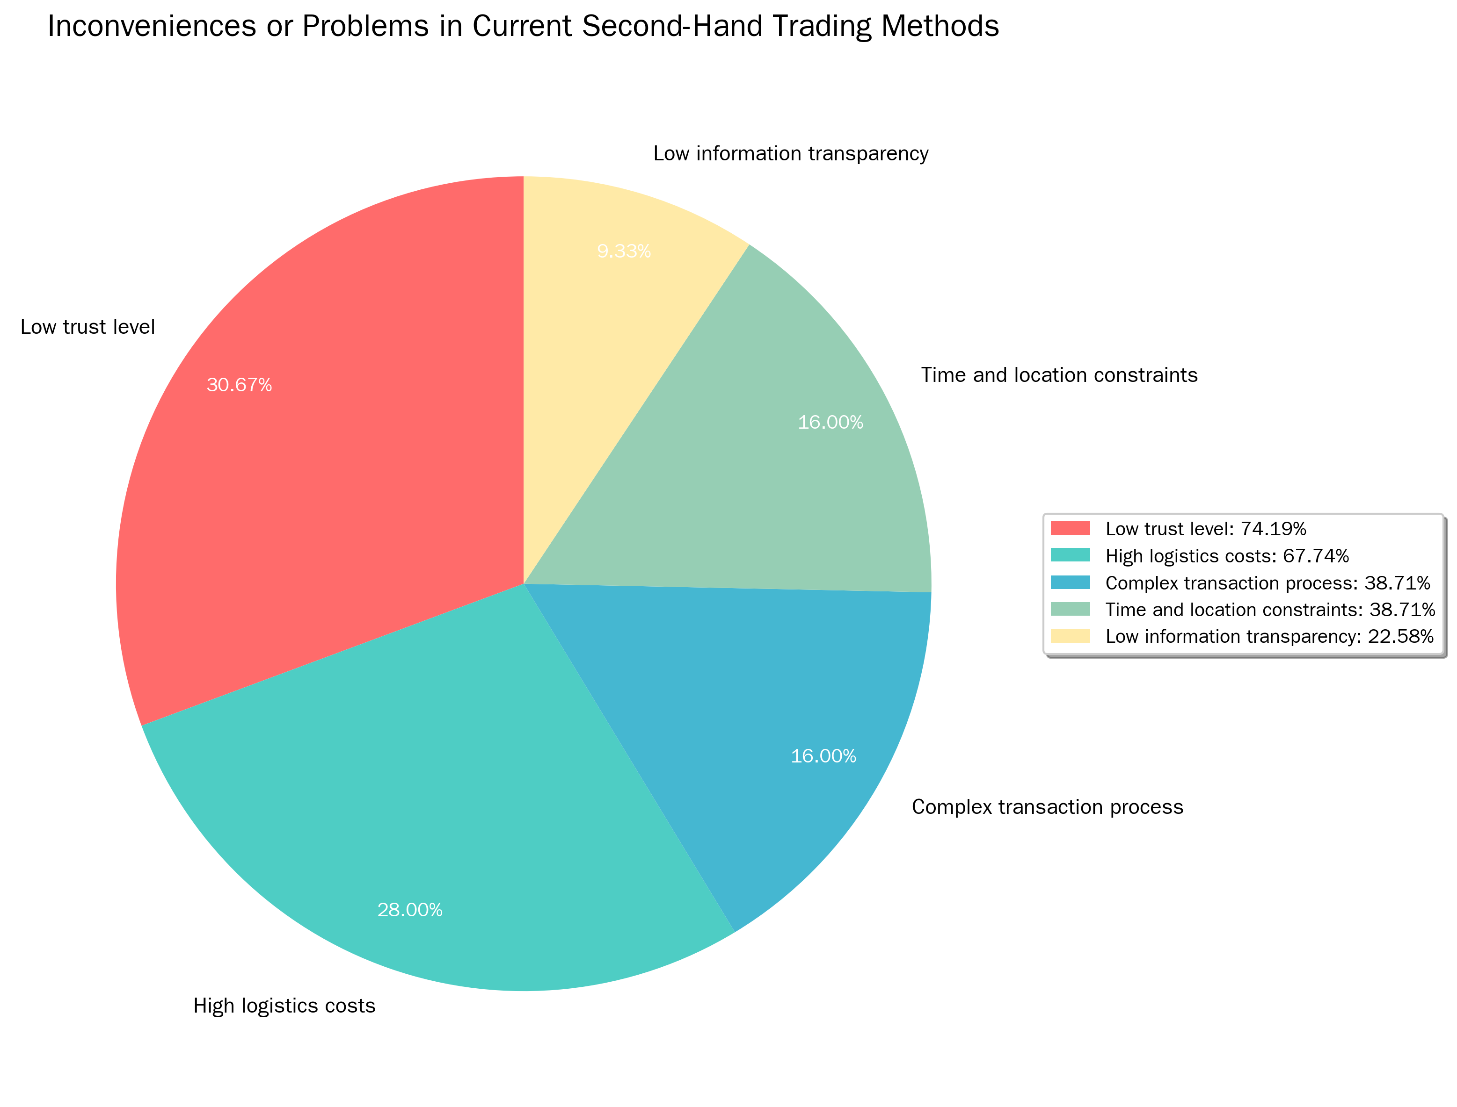

Figure 2

**a) Critical Efficiency Deficiencies**

The current system creates substantial friction in matching supply with demand:

1. Extended Time-to-Transaction: Even when both buyers and sellers are actively seeking each other, the average time from listing to successful transaction ranges from 2-5 days, with many potential matches never occurring at all.
2. High Opportunity Costs: Students waste considerable time on platform management rather than actual trading. Research indicates students spend an average of 30-45 minutes daily just monitoring various groups and repeating their search queries.
3. Missed Connections: Compatible trading partners frequently fail to connect due to timing mismatches. A seller posting an item during class hours might miss interested buyers who only check groups in the evening.

**b) Fundamental Discovery Limitations**

The absence of modern discovery tools creates significant barriers:

1. Search Dependency on Memory: Users must remember specific keywords or constantly refresh group chats rather than using targeted searches. This "search by scrolling" approach has extremely low efficiency.
2. No Personalized Recommendations: The system cannot learn user preferences or suggest relevant items based on past behavior, course enrollment, or expressed interests.
3. Category Confusion: Without standardized categories, similar items are described differently, making comprehensive searching impossible. A student seeking "calculus textbook" might miss listings for "math book" or "Math 101 materials."

**c) Transaction Reliability Issues**

The informal nature of current transactions introduces multiple failure points:

1. Conversation Fragility: Trading discussions can be interrupted by unrelated group messages, causing participants to lose track of their negotiations. Important details like meeting arrangements require constant repetition.
2. No Commitment Mechanisms: Either party can abandon transactions at any stage without consequence, leading to frustration and wasted time for the other participant.
3. Information Loss: Critical transaction details (final price, meeting location, condition descriptions) are buried in chat histories, requiring participants to scroll back through conversations to confirm arrangements.

**d) Trust and Safety Concerns**

The current system lacks basic trust and verification mechanisms:

1. Identity Uncertainty: Participants have no way to verify they're dealing with actual students, creating potential security risks during in-person meetings.
2. No Reputation System: There's no method to identify reliable trading partners or avoid users with histories of failed transactions.
3. Dispute Resolution: When issues arise (misrepresented items, no-shows), there's no formal process for resolution, leaving participants with limited recourse.

2.3 Impact Assessment

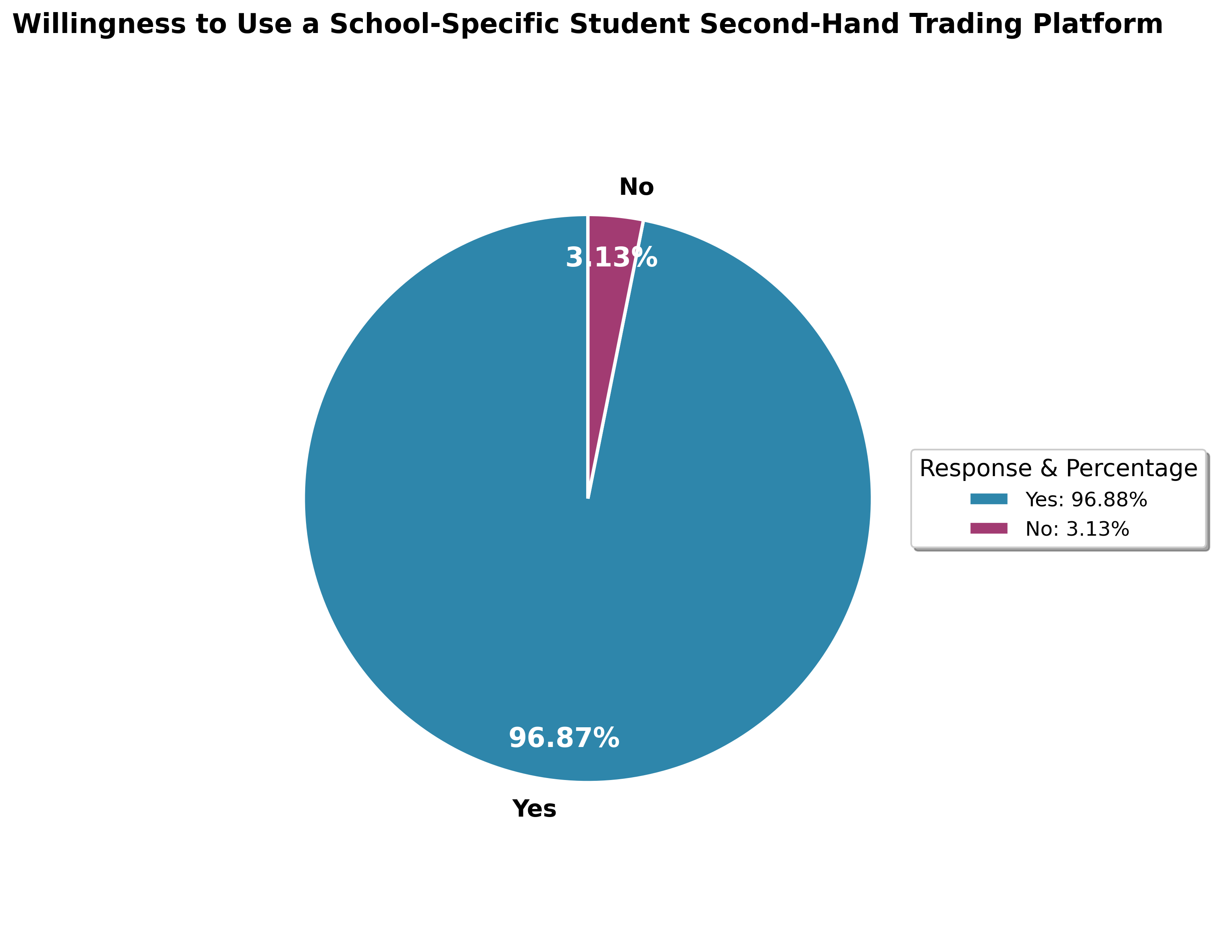

Figure 3

By addressing these three core problem areas—efficiency, discovery, and transaction reliability—our platform can transform the campus trading experience from a frustrating, time-consuming process into a streamlined, reliable system that serves students' actual needs while saving time and reducing friction in the trading process. The solution will specifically target the pain points identified through student feedback and observational research, creating a trading environment that is both efficient and trustworthy.

# 3. Proposed Project Description

## 3.1 System Features

Our platform will include the following modules:

a). User Module: Students can only register with their campus email, login, and manage a personal profile.

b). Item Module: Users can publish items with title, description, price, category, and image; also edit or remove items later.

c). Transaction Module: Supports trade initiation, simple order generation, and automatic notifications for key steps.

d). Search & Recommendation: Provides keyword and category filtering; a simple recommendation (e.g. “Students who bought X also viewed Y”) will help match demand.

## 3.2 Business Value

a). For buyers: Locate second-hand items efficiently, often saving money compared to buying new.

b). For sellers: Easily find buyers, clear unused goods, and regain some value.

c). For the campus: Encourages re-use and recycling, reduces waste, and supports a sustainable student environment.

## 3.3 Example Scenario

For example, student Li needs a second-hand rice cooker. He logs into our platform and searches using the keyword rice cooker. The system shows a list of items, and one matches his need, posted by student Wang. Li contacts Wang through the built-in message feature and both receive automatic prompts to confirm each step. This process is much faster and far more reliable than traditional group message.

# Plan of Work

4.1 Timeline

**Week 1**: Requirement collection, analysis of existing solutions, use case diagram design.

**Weeks 2–4**: Functional development:

• User module (registration, login)

• Product posting & search module

• Transaction and notification module

**Week 5:** Front-end integration, database optimization.

**Week 6:** System testing and debugging.

**Week 7:** Documentation and presentation preparation.

4.2 Product Ownership

Group 1: User & Transaction Core Team

Members: Zhang Zhichao and Chen Baifu

Functional Features Responsible For:

1. User Authentication System: Student email verification registration process, User login/logout functionality, User profile management
2. Core Transaction Functions: Item posting, editing, deletion, Item list browsing, Item status management (on-sale/sold)
3. Database Design & API: User and item table design, RESTful API development, Data validation and error handling

• Qualitative Properties Committed To: Ensure user registration process completes within 3 steps

Group 2: User Experience & Interface Team

Members: Wang Zhaohan

Functional Features Responsible For:

1. Frontend Interface Development: Responsive page layout, Mobile adaptation, Unified UI components
2. Search & Navigation Functions: Item search functionality, Category browsing, Page routing management
3. System Deployment & Testing: Frontend build and optimization, System deployment and launch, Basic functionality testing

• Qualitative Properties Committed To: Cross-browser compatibility support

4.3 Technology Stack (Preliminary decision)

Front-end: React + Ant Design Mobile

Back-end: Node.js + Express

Database: MySQL

State Management: Zustand (lightweight)

4.4 URL of Our Project’s Web-Site

[Projects · Second-hand-platform](https://github.com/Xile1008/Second-hand-platform/projects?query=is%3Aopen)

**5. Reference**

https://www.wjx.cn/report/332316353.aspx